## Deron Witmer

## Yimeng Gao

## Runjia Zhao

## Orupa Mbwana

Tawakalitu Alaka

Chris Pence

Table of Content:

Work Breakdown Structure 3

Schedule Gantt Chart 4

Selected Software Process 4

Change Management Plan 5

Sources: 5

## 

## 

## 

## Github

<https://github.com/dwitmer1989/AWD_Final_Project>

## Work Breakdown Structure

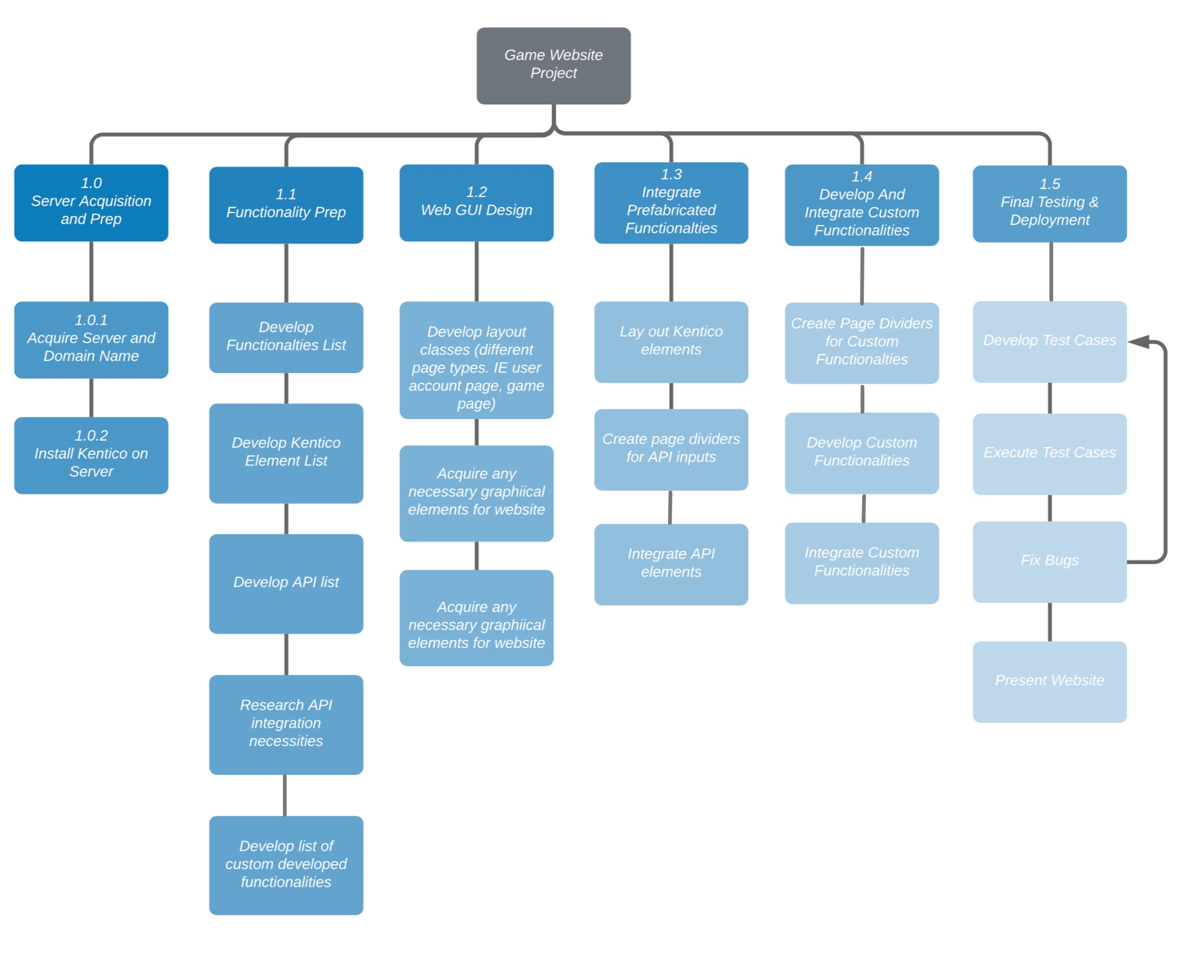

## Schedule Gantt Chart

## 

## Selected Software Process

The team has elected to follow the Agile Model for the development of the online gaming website project.

The Agile Development Model follows an iterative approach that promotes a process of continuous planning and feedback that allows the team to be able to easily adapt any changes in requirements to the project. It lets teams deliver a prototype of the software, and then improve upon it with every cycle.

In Agile Development, testing is integrated into the project from the beginning, and is carried out throughout the software process. This helps to ensure that any quality issues can be identified and resolved early in the project, and a great quality product delivered.

The Agile Development Model is fun and enjoyable, fosters an active involvement of each team member, and empowers project teams to work creatively and effectively to deliver a final product that meets the client’s requirements.

## Change Management Plan

A change management plan could help us to manage the change process, ensures control in budget, schedule, scope, communication, and resources. Therefore, to ensure our team handle every change properly and make our project go smoothly, we figure out a change management plan in face of changes in the following steps:

1. **Find out the reasons and the scope of the change:** Once a change is needed or detected, we will first find out the reasons of the change and figure out who the change will impact on, what influences the change would bring to the positions of the group members, the process and procedure of the work, the timeline of the project, and the structure of the project.
2. **Figure out the stakeholder of the change and the change management team:** To proper deal with the change, we will find out a sub-team in our team to mainly take care of the change in our project, including overseeing the change, demonstrating each member’s responsibility, set a time schedule and make an implementation plan for the change.
3. **Access the change and identify the benefit of the change:** We will clarify what improvement the change would bring to our original project by comparing with the former plan without change and find out the advantages and benefits of the change.
4. **Request approval of the change and keep track of the change after approved:** We will request change and approve it to avoid unexpected or casual change, we will keep every change in control and track it through the whole process of the change.
5. **Make change communication plan:** The communication among the team members are very significant parts of a project, and it should be consistent and thorough. Every member of the group should have a good understanding of the change, the benefit of the change, and keep in contact all over the project. We will have regular meetings to allow group member ask questions, express attitude and keep every group member on board.

## Sources:

[1] <https://resources.collab.net/agile-101/agile-software-development-benefits>

[2] <https://www.glowtouch.com/waterfall-vs-agile-good-bad-misunderstood/>

[3] <https://www.liquidplanner.com/blog/13-reasons-agile-project-management/>

[4] https://dzone.com/articles/you-will-thank-us-5-good-reasons-why-agile-should

[5] <https://www.smartsheet.com/expert-guide-writing-effective-change-management-plan>

[6] https://www.projectmanager.com/training/how-to-make-a-change-management-plan